**PIZZA SALES SQL QUERIES**

1. **KPI’s**
2. **Total Revenue**

SELECT SUM(total_price) AS Total_Revenue

FROM pizza_sales

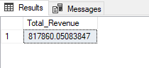

1. **Average Order Value**

SELECT SUM(total_price) / COUNT(DISTINCT(order_id)) AS Average_Order_Value

FROM pizza_sales

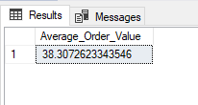

1. **Total Pizzas Sold**

SELECT SUM(quantity) AS Total_Pizzas_Sold

FROM pizza_sales

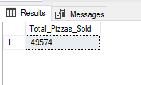

1. **Total Orders**

SELECT COUNT(DISTINCT(order_id)) AS Total_Orders

FROM pizza_sales

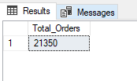

1. **Average Pizzas Per Order**

SELECT CAST(CAST(SUM(quantity) AS DECIMAL(10,2)) / CAST(COUNT(DISTINCT(order_id)) AS DECIMAL(10,2)) AS DECIMAL(10,2)) AS Average_Pizzas_Per_Order

FROM pizza_sales

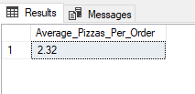

1. **CHARTS REQUIREMENTS**
2. **Hourly Trends for Total Pizzas Sold**

SELECT DATEPART(HOUR, order_time) AS Order_Hour, SUM(quantity) as Total_Pizzas_Sold

FROM pizza_sales

GROUP BY DATEPART(HOUR, order_time)

ORDER BY DATEPART(HOUR, order_time)

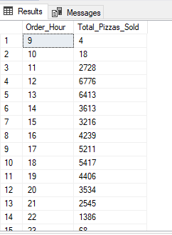

1. **Weekly Trends for Total Orders**

SELECT DATEPART(ISO_WEEK, order_date) AS Week_Numner, YEAR(order_date) AS Order_Year,

COUNT(DISTINCT(order_id)) AS Total_Orders

FROM pizza_sales

GROUP BY DATEPART(ISO_WEEK, order_date), YEAR(order_date)

ORDER BY DATEPART(ISO_WEEK, order_date), YEAR(order_date)

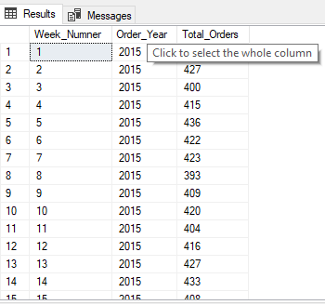

1. **Percentage of Sales by Pizza Category**

SELECT pizza_category, SUM(total_price)*100 /

(SELECT SUM(total_price) FROM Pizza_DB.dbo.pizza_sales WHERE MONTH(order_date)=1) AS Percentage_of_Sales

FROM Pizza_DB.dbo.pizza_sales

WHERE MONTH(order_date)=1 -- this clause means we are filtering the data to show only January

GROUP BY pizza_category

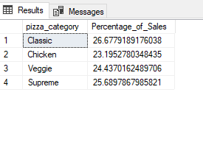

1. **Percentage of Sales by Pizza Size**

SELECT pizza_size, CAST(SUM(total_price)*100 /

(SELECT SUM(total_price) FROM Pizza_DB.dbo.pizza_sales WHERE DATEPART(quarter, order_date) = 1) AS DECIMAL(10,2)) AS Percentage_of_Sales

FROM Pizza_DB.dbo.pizza_sales

WHERE DATEPART(quarter, order_date) = 1

GROUP BY pizza_size

ORDER BY Percentage_of_Sales DESC

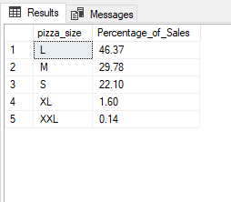

1. **Top 5 Best Sellers by Revenue, Total Quantity and Total Orders**

SELECT TOP 5 pizza_name, SUM(total_price) AS Total_Revenue

FROM Pizza_DB.dbo.pizza_sales

GROUP BY pizza_name

ORDER BY Total_Revenue DESC

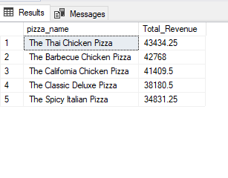

1. **Top 5 Best Sellers From Bottom**

SELECT TOP 5 pizza_name, SUM(total_price) AS Total_Revenue

FROM Pizza_DB.dbo.pizza_sales

GROUP BY pizza_name

ORDER BY Total_Revenue ASC

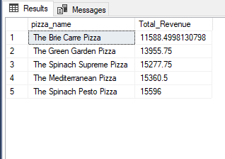

1. **Top 5 Best Sellers by Quantity**

SELECT TOP 5 pizza_name, SUM(quantity) AS Total_Quantity

FROM Pizza_DB.dbo.pizza_sales

GROUP BY pizza_name

ORDER BY Total_Quantity DESC

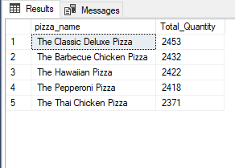

1. **Top 5 Best Sellers From Bottom**

SELECT TOP 5 pizza_name, SUM(quantity) AS Total_Quantity

FROM Pizza_DB.dbo.pizza_sales

GROUP BY pizza_name

ORDER BY Total_Quantity ASC

